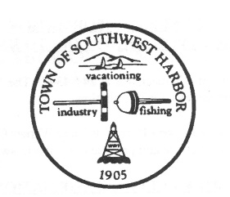
Planning Board Agenda

Southwest Harbor Thursday, April 15, 2021 @ 6:00 PM
via Zoom

I. Call to Order/Roll Call

II. Adoption of the Agenda

III. Approval of Minutes: April 1, 2021

IV. Public Hearing – Meristem LLC

V. Old Business:

Meristem LLC
11 Seal Cove Road Tax Map 007 Lot 021 B Zone
Adult Use Marijuana Retail Store

VI. New Business

Salvoi Holdings – dba Harbor Cottage Inn
9 Dirigo Road-Tax Map 004 Lot 100 B Zone
Change/Additional use to serve meals and liquor to public
Determination of Complete Application

VII. CEO Issues – None

VIII. Next Meeting Date:

Regular Planning Board Meeting, Thursday May 6, 2021, @ 6:00 PM

IX. Adjourn Meeting

